London Region 2016 Junior Series Report

Author: Jim Desmond – London Junior Coordinator

- 2016 Junior Series Summary
It was a super Junior Series this year comprising 10 excellent events, and providing fantastic racing experience for all the young athletes. I’ve been involved in London Junior Series for 7 years, and I will reflect on the 2016 as the best we’ve had.

In all categories there was great camaraderie and mutual respect evident, and the competition throughout has been conducted in a spirit of sportsmanship which is to the credit to all of the participating children, parents and coaches.

The number of participants was close to record level, and the margins between many of the leading competitors was closer than ever resulting in some very exciting racing and small points differences separating them in the end-of-Series place rankings.

- The Winners
These are the individuals who ranked highest in the Junior Series, and so will be receiving the end-of-Series awards.
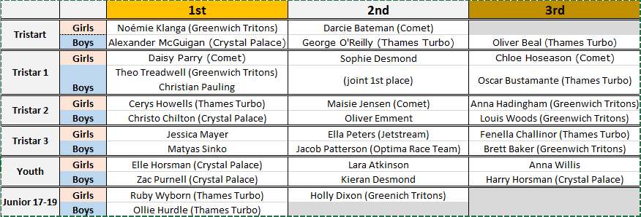

Note: all the statistics below relate to just London-eligible athletes (i.e. qualified by club affiliation or residency). All non-London athletes have been excluded from the numbers and commentary.

- Analysis by Event
- London Participants By Event
This chart shows the number of London-qualified children participating in each of the 10 series events.
Note the events are order by type (triathlon, aquathlon, duathlon) rather than chronological order.
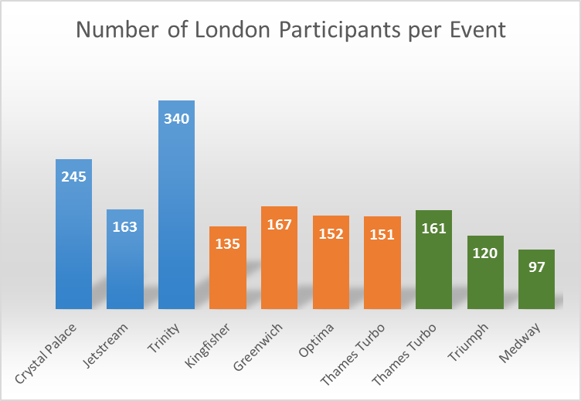

- Analysis of Total Participants
This section focuses on individuals who competed in one-or-more events, and the numbers are not influenced by how many events each took part in – this is intended to give a measure of the level of exposure that it has the Junior Series has within London.

- 2016 Series Participation by Category/Gender
This chart shows– the stats are presented by Category and Gender.
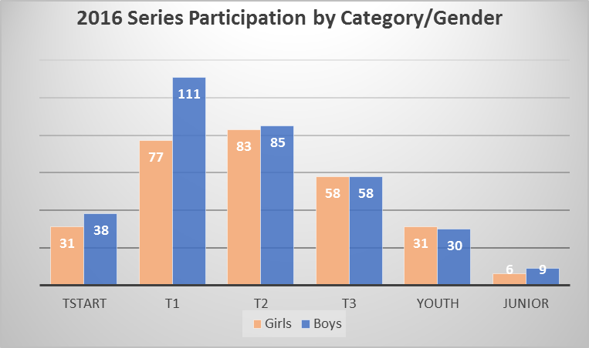

- Historical Record of Athletes Competing
This chart shows the number of London athletes contesting a Series event.
In 2016 the total was 617 –slightly down on the highest ever of 649 in 2015.
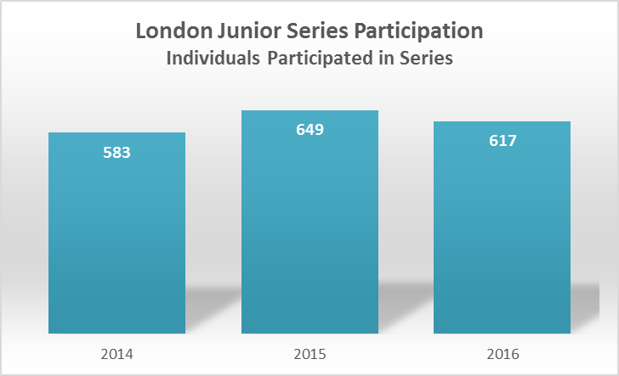

The number of event finishes recorded in the 2016 Series was however a new record 1731 – this is a product of the athletes competing a higher average number of events (average of 2.81 per athlete).
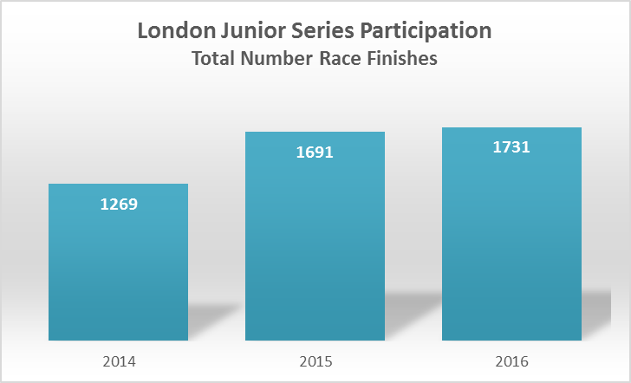

- Number of Series Events Participated
This chart shows the 617 athletes who participated in the Series grouped by the number of events they completed.
The stand-out stats are:
- 44% completed multiple events
- 13 individuals were ever-present completing all 10 races – a testament to their remarkable resilience and commitment (and also that of their parents!!).
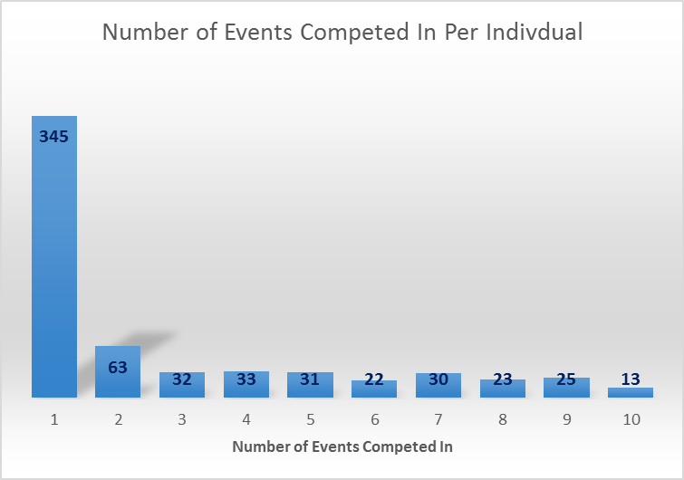

- Analysis of Series Completion
The analysis in this section relates onto to the children who completed the full number of events to qualify for the Series rankings (i.e. 2 X triathlon, 1 X duathlon, 1 X aquathlon).
These numbers reflect those who have made a serious commitment to the sport.

- Number of Athletes Completing the Series
The lower total in 2016 was a consequence of the lower participation levels in duathlons, with many completing their triathlons and aquathlons, but missing the mandatory duathlon.

The major contributory factor for this were that 2 of the duathlons were new events, with one being out of region (Medway), and another (Triumph) going live later than we would have liked, and so they both had a lower number of participants than would be expected normally.

However we needed this events to give the Series balance, both were excellent events and very popular, and I am confident that if included in a future Series then they’d have higher participation levels.

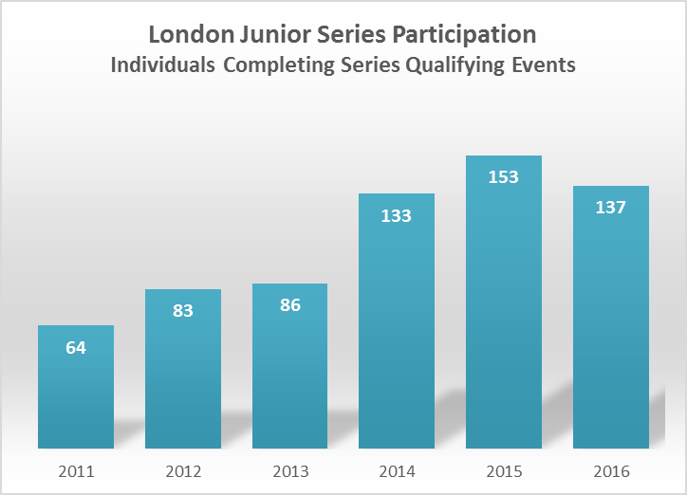

The chart below shows the same stats for the past 6 years decomposed by category.

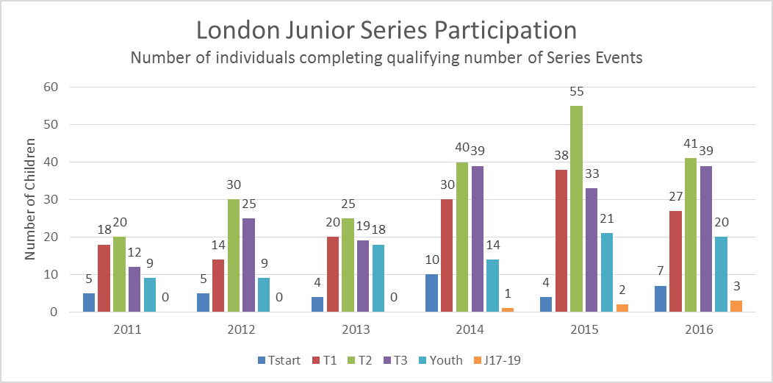

- Decomposition by Gender
These charts are based on the 137 children who completed the series.

The most notable development is that we now have almost reached gender-parity (following a historical trend of greater numbers of boys than girls).

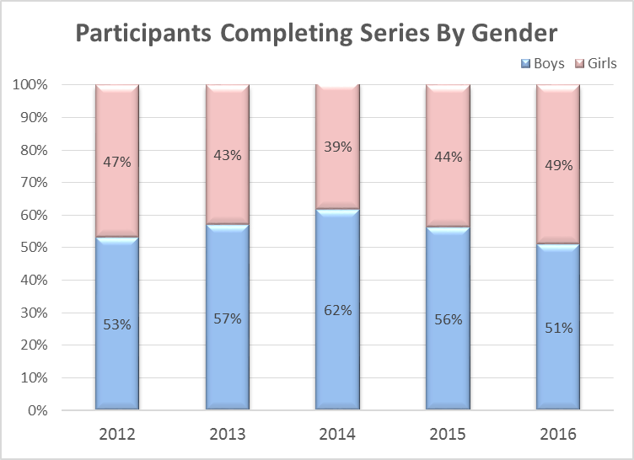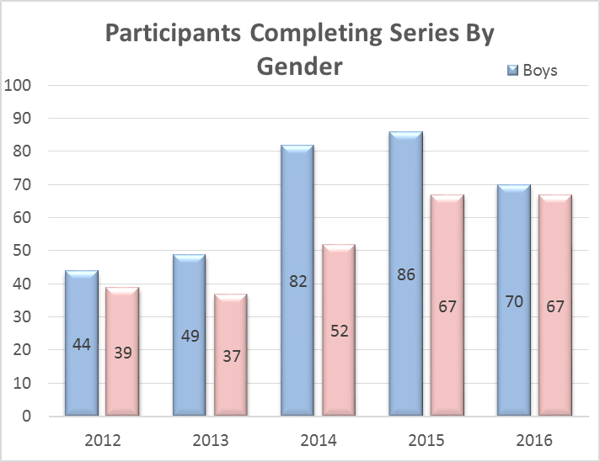

- Analysis by Club
- Junior Series Participation by Club
The chart below shows how many individuals from each club competed in the 2016 Junior Series.
Note:
- All age categories are included, and how many times someone competed does not influence this chart as everyone who participated scores the same.
- Approximately 62% of Series participants were not affiliated to any triathlon club – this chart includes just the 38% who were affiliated.

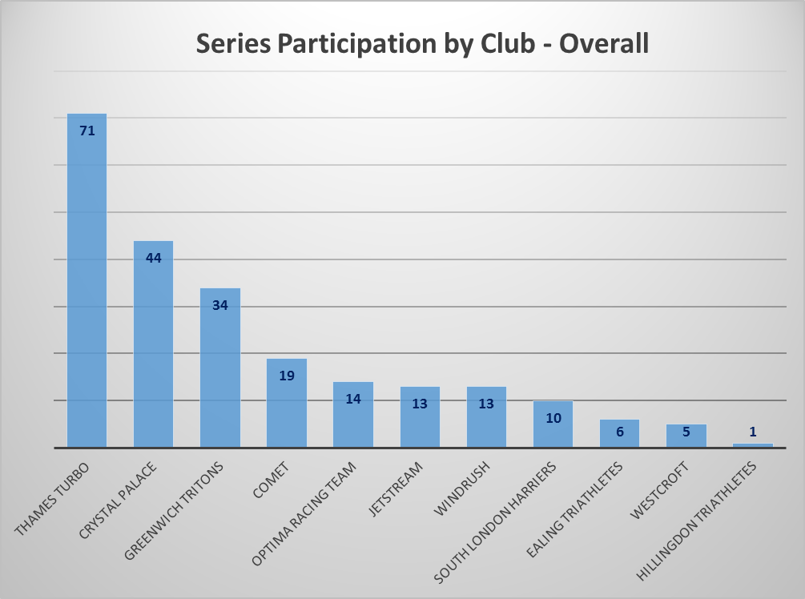

- Junior Series Awards by Club
The table below shows the number of Series trophies going to each club reflecting the relative strength of the leading athletes between the London clubs.

Note:
Only the main categories (Tristar 1, Tristar2, Tristar3) are represented in the chart –
- Tristart & Junior have been excluded because insufficient numbers completed the series.
- Youth has been excluded because many of the leading athletes contest the Super Series events rather than London Series, and so London ranking do not reflect the strength of a club.

Club | 2016
Greenwich Tritons | 4
Thames Turbo | 3
Comet | 3
Crystal Palace | 1
Optima | 1
Jetstream | 1
No Club | 5

Approximately ¼ of the 18 trophies awarded to athletes who are not in a triathlon club, reflecting the shortage of clubs within the region that can address the needs of the performance juniors in particular.

