London Regional Managers Delivery Report: Region AGM 2016

Please find below the London Region Manager’s report for the 2016 season to end of September 2016.

1. Coaching Delivery

In 2015-16 the coach education programme at the time of the AGM consisted of one Level 1 and one Level 2 Triathlon coaching course. Both of these courses filled so additional course were planned for the 2015-16 programme. These courses didn’t fill.

2015-16 additional courses
Level 1 (89691)
Venue: Crystal Palace NSC
Dates:
Status: 14 took the course.
Forecast: Course incurred a small loss of approximately -£220 to the region.

Level 2 (89974)
Venue: Crystal Palace NSC
Dates:
Status: 14 took the course
8 candidate have a L1 qualification – 6 direct entry and so new coaches.
Forecast: Course made a surplus of approximately £1,300 for the region.

The course programme for 2016-17 has initially again one Level 1 and one Level 2.

2016-17 Initial Course programme
Level 1 (94073)
Venue: Crystal Palace NSC
Dates:
Status: 16 booked on the course.
Forecast: Course estimated to made a small surplus of approximately £140 for the region.

Level 2 (94074)
Venue: Crystal Palace NSC
Dates:
Status: 16 booked on the course
8 candidate have a L1 qualification – 6 direct entry and so new coaches.
Forecast: Course estimated to made a surplus of approximately £2,750 for the region.

Currently assessing whether to run additional courses in 2016-17.

Level 2 course costs for Level 2 were reduced by £10 to £540 for 2016-17. Level 1 course fees remained the same at £350.

Coaches Continuous Professional Development (CPD)

An Open Water Coaches Workshop was held at West Reservoir in July 2016 this was fully booked with 10 coaches attending.

2. Regional Delivery

Club Development

There are 51 triathlon clubs affiliated for 2016 (49. 2015). The number of clubs is holding steady, and has been hovering around 50 for the past 5 years. There were 2 new clubs registered in 2016, E & Y Triathlon and Traix Triathlon.

Club Distribution
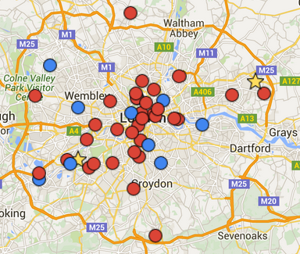

Events

The number of registered events for the 2016 season is down on 2015 to 109 from 135. This is primarily down to reduced number of GO TRI events in the region. In 2015 there were 47 GO TRI events this year we have 23 GO TRI events registered so far in 2016.

The larger events are continuing to show a participation drop off, whilst the club programme on the whole maintaining participation rates. The data collected is from published results on the event websites.

The number of participants (race starts at registered events,) at the end of September there were 15,001 (2016) verses 20,247 at this time of the season in 2015.

 | Events (to Sept) | Participants | Male | Female
2016 | 86 | 15,019 | 9,862 (66%) | 5,157 (34%)
2015 | 107 | 20,247 | 13,834 (68%) | 6,413 (32%)

(Note no ITU event in 2016 in Hyde Park 4,500 participants)

Event Participation Distribution

The events programme had been concentrated in the south-west and west of London. Over the past few years I have been working to create a more even geographically distribution of events. And in the last two years the eastern area of London has seen a massive growth in the number of events.

This is primarily down to our partnership working in the world class facilities in the Queen Elizabeth Olympic Park, VeloPark and the open water facility at west reservoir and the roll-out of the GO TRI initiative.

There is still some work to do to make the event coverage such that there is an appropriate event within easy reach for those looking to start their journey in our sport. The northern area of London and the southern fringes of the region are area where more work needs to be done to develop an events programme.

Event Geographic Distribution

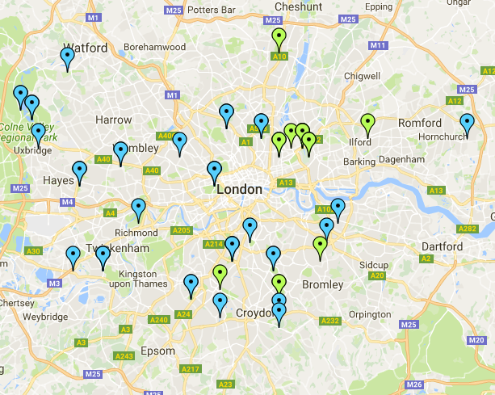

British Triathlon Membership

Membership in of British Triathlon is growing with memberships taken out in 2016 rising to 3,617 from 2,492 in 2015. There has been a sharp increase in female memberships and a drop in the percentage of BT members in London that are members of affiliated triathlon clubs.

 | Total BTF Memberships  in London | Females | Males | Members of Triathlon Clubs
2016 | 3,617 | 1,254 (35%) | 2,363 (65%) | 1,663 (46%)
2015 | 2,492 | 729 (29%) | 1,763 (71%) | 1,528 (61%)

Membership distribution

2015 2016
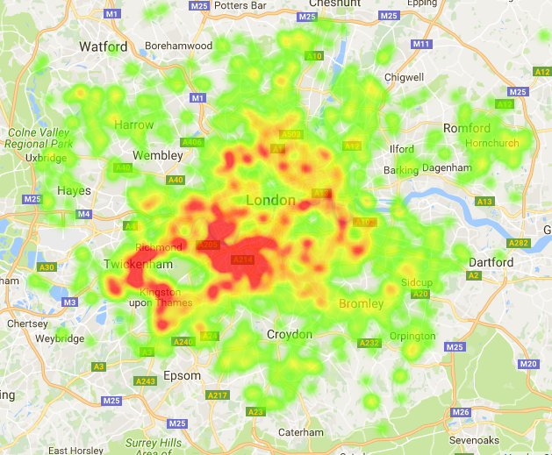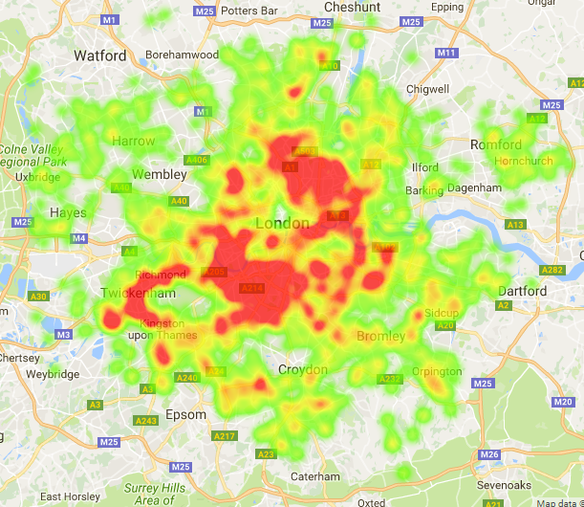

Highlights 2016 and plans for 2017

Highlights
- The VeloPark programme has continued in 2016.
  - Since the inception in 2014 there have been 45 events with 3035 participants.

- London Youth Games included RELAY Aquathlon for 16-19 years old.
  - Team entered were low but numbers will increase By including a team relay option and using GO TRI to engage with London Boroughs.

2017 plans
- Continue to working with London Youth Games to extend the Aquathlon to those 16-19 years old. By including a team relay option and using GO TRI to engage with London Boroughs.
  - Proposal includes GO TRI events and training to boroughs to provide entry level participation opportunities for all age groups.
  - Aims to create a network of GO TRI activities across the whole region in partnership with the London boroughs and Leisure providers.
- Sport England funding will be announced for the next cycle in the New Year. The funding level will determine the details of the 2017-21 work programme and targets.

