Regional Managers Delivery Report:
South Central Region AGM
29th September 2018

Please find below the South Central Region Manager’s report for the 2018 season to end of September 2018.

1. Coaching Delivery

The course programme for 2018 - 2019 has two Level 1 courses (at two different venues) and two Level 2 courses (at two different venues)

2018 – 2019 Initial Course programme
Level 1
Venue: Sibford School, Banbury, Oxfordshire
Dates: 10th & 11 th November, 9th December 2018
Status: 16 booked on the course.

Level 1
Venue: West Hill Park School, Fareham , Hampshire
Dates: 27th & 28th October, 25th November
Status: 6 to date booked on

Level 2
Venue: Sibford School
Dates: 1st & 2nd December , 19th 20th January, 27th April
Status: 8 booked on to date

Level 2
Venue: West Hill Park School
Dates: 15th & 16th December , 26th & 27th January , 19th May
Status: 6 booked on to date

Important to note that West Hill Park course only became live for booking mid September .

Level 2 course costs £540 with a fast track fee of £50. Level 1 course fees remained the same at £350.

2. Regional Delivery

Club Development

There are 59 triathlon clubs affiliated for 2018.

2018: 59
2017: 60
2016: 57
Club Distribution 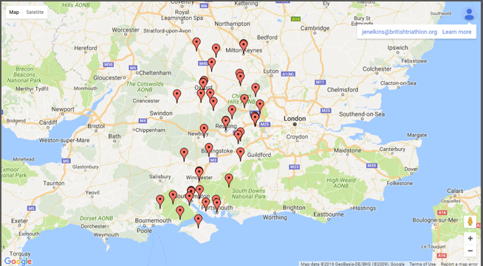

Events

The number of registered events for the 2018-19 season is 99, with 41 Go Tri Events.
 | Events (to Sept) | Participants
2018 | 99 | 22058

Event Participation Distribution

The spread of events and Go Tris is fairly even throughout the region.

The other area of focus on both normal events and also Go Tri is Buckinghamshire, this shows a real need for events as there are some large clubs in the county . This is another key area which needs more development but with two clubs Team MK and Pheonix Tri MK wanting to run GO TRIs hopefully this will be covered soon.

Event Geographic Distribution

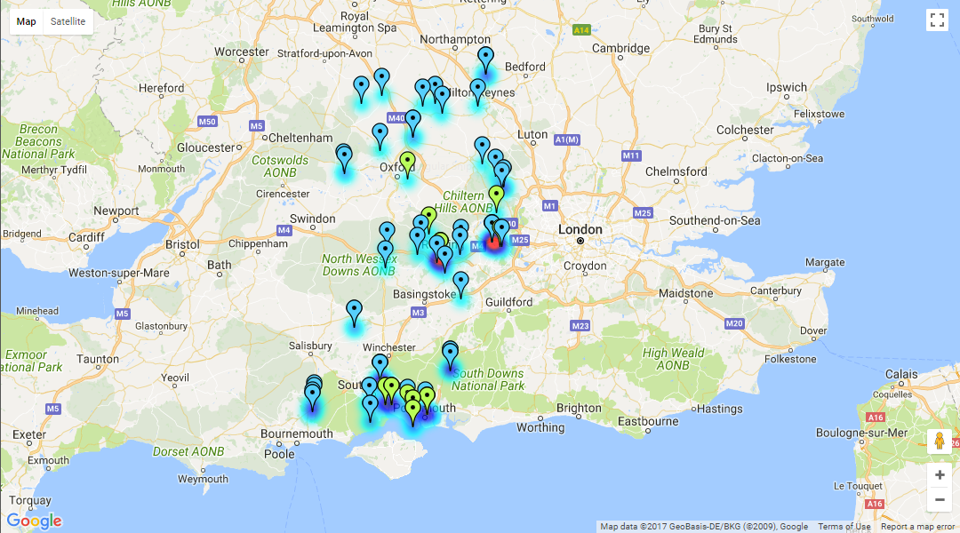

2018/19 plans

The main two focus points are getting ALL junior clubs through their Bronze Tri Mark Club Accreditation and GO TRI participation.
Bronze Accreditation

Currently working hard on getting Junior Clubs started with their Bronze Accreditation , currently have the following accredited or very nearly, just awaiting a few DBS checks!

- Phoenix Tri MK
- Farnham Tri Club
- Southampton Tri Club
- Portsmouth Triathletes
- Reading Rascals
- Bicester Tri Club
- West Hill Park
- Try a Tri Guernsey
- EVO tri club
- Perform Academy Tristars
- Bayside Tri Club (no junior section)
- Try a Tri Guernsey
- Jersey Tri Club
- Tri Henley

This is our main target at the moment for Regional Managers as we need all junior clubs accredited by the end of the year.

GO TRI
Currently at 73% of target for participation in GO TRI in the South Central, with a shortfall of 450 taking part. (1345 have taken part out of a target of just over 1800)
Currently looking at clubs which can run some winter duathlon series as GO TRIs to try and boost these number.

